# CS 340 README

## About the Animal Shelter Dashboard

The Animal Shelter Dashboard is a client-facing web application that will allow Grazioso Salvare staff to view data from the Austin Animal Center in a data table format. The Dashboard will have options to allow the staff to filter the data in different categories to support their search for certain kinds of dogs. Along with the data table will be a map that will give the staff members a location for the animals that will update as they choose different kinds of dogs. Another visual graphic we added is a pie chart that will assist the staff members in quickly reviewing the different dogs in the database and the staff members will be able to see the changes in the map and pie chart as they interact with the data. The Dashboard application database is powered by MongoDB and uses a Python module (and CRUD operations) which will allow the data to be read in the dashboard application.

## Motivation

Grazioso Salvare identifies dogs that are good candidates for different search and rescue operations such as water rescue, mountain or wilderness rescue, disaster rescue, and individual tracking. Our mission was to build a Dashboard application that will help with their search for good working dogs to support in these critical rescue operations. Some dogs are better at certain rescues so we created a dropdown menu that would allow the Grazioso Salvare staff to filter the dogs to find the best candidate. For example, a Labrador Retriever mix is a good candidate for water rescue if they fit in the age bracket.

## Tools Used and Rationale

1. **MongoDB** is a popular document database that is used in this project because of its flexibility, speed, and the ability to scale up or down depending on business needs. The MongoDB database can store large amounts of data and supports full indexing which will allow the users to perform search inquiries in a faster and more controlled manner for better search results. MongoDB was used as our model component of development because the data was large and unfiltered, and we needed to load it into a dashboard framework for our clients to interact and use the data. As MongoDB acts as our model layer hosts the datasets after they are imported in MongoDB. MongoDB is also used with Python as the backend server programming language. MongoDB and Python use a Python driver called PyMongo which will allow communication between MongoDB and Python such as creating the MongoClient. PyMongo has many tools that will allow communication with the MongoDB servers and the ability to do CRUD operations on the database.
2. **Python**-CRUD-Module is used as middleware to allow the database to interact with the client side. We created a Python CRUD (Create, Read, Update, Delete) Module that allows us to grab the documents from MongoDB and load them into the dashboard framework by using the CRUD operations. For example, our read operation in the Python module will read data from the MongoDB database and show the data on the Dashboard for our client to view and interact with. MongoDB and Python work very closely together as one serve as the database (Mongo) and the other (Python) serves as the middleware allowing the data to be interacted with once loaded into the Dashboard Application. The Python layer can be thought of as the controller structure using the Module CRUD operations to perform different tasks on the data. For example, the data table we used in the Dashboard Application utilizes the read function by setting up the Mongo Client and using the animal collections. Without this layer the application would not have any data to interact with, so taking your time and setting up the python module is a important step.

**Python CRUD Module**:

* **CREATE** function will allow users to create documents and insert them into the database and animal collection. Using insert_one while passing the data and return True if successful insert, else False.
* **READ** function will allow users to read documents from the database and we use find () method because we must work with the MongoDB cursor and use a list for the read function. Return read result; else the list is empty.
* The **UPDATE** function allows updates to documents in the database, and we use update_many and a $set operator. Return the number of modified objects in the collection.
* **DELETE** function will allow a user to delete documents from the database using delete_one while passing the data. Return the number of objects modified in the collection.

1. **Jupyter Notebook** and Dash Framework. Jupyter Notebook was used for the Animal Shelter Dashboard Application to test our Python CRUD commands, test our Dashboard framework, and deploy our Animal Shelter Dashboard application. In the Jupyter notebook we completed many tasks to test all operations (CREATE, READ, UPDATE and DELETE) of the application and test the different components such as the different libraries that we imported and used for the different components used throughout. The Dash components from Plotly and Leafly (described below) work together as view in the application model for our web application. This is the third layer (client-facing side) of the animalShelter application which the staff members at Grazioso Salvare will be interacting with frequently. The view layer in the application hosts the data table, pie chart, geolocation map, dropdown menu, and input boxes that the end user with be interacting with. One important aspect of the Dashboard application is the data-table and the Python Module. The Python Module needs to be able to access the database from MongoDB and read documents from the animal collection database and then load the data into a data table format. Below are the components we used to make the Application interactive and easy to use.

* **Dash components from Plotly** and the libraries were used to have interactive components on the Dashboard such as dropdown menus and have input placeholders for users to input such as, a dog’s breed or a name. The drop-down menu is used on the Animal Shelter Dashboard application by allowing the user to filter results by certain recuse dogs. Also, on the interactive data table will allow the user to input a dog’s breed and hit enter for a search query.
* **Dash Data-Table from Plotly** libraries are used to format the documents from the database (MongoDB) into a table format on the application for users to view and interact with. There are different features developed to support data sorting, paging (used to create more pages if the data needs it such as page 1, 2, 3…), editing the cells, sort mode to multiple to allow different types of sorting and page size to control the amount of data on the table at any given time. Libraries include “from dash import dash_table” and “import panda as pd” for plotting.
* **Pie Charts in Python from Plotly** was implemented by importing libraries to show a pie chart showing all the different kinds of dog breeds and the chart will update depending on the search results and/or what the user selects. For example, in the dropdown menu, if the user selects mountain rescue the pie chart will update with all the different breeds available for mountain rescues. Libraries used “import plotly.express as px”.
* **Map Component for Dash Leaflet** is used for map location of the different dogs and cats that are in the database. Dash Leaflet uses libraries called the geolocation component reads the longitude and latitude in the data table and shows the location on a map, along with the animal’s name and breed. As the user selects different animals the map will update to show the current dog or cat selected. Libraries used “from dash import Dash” and import “dash_leaflet as dl”.

## Getting started

To get a local copy up and running follow these simple steps with examples.

1. Install required software and tools needed to create an Animal Shelter Dashboard Application.

* MongoDB, latest version. Link: [MongoDB: The Developer Data Platform | MongoDB](https://www.mongodb.com/)
* Python and a Python IDE such as Spyder, latest version. Link: [Welcome to Python.org](https://www.python.org/)
* PyMongo, latest version Link: [Installing / Upgrading - PyMongo 4.6.1 documentation](https://pymongo.readthedocs.io/en/stable/installation.html)
* Jupyter Notebook latest version Link: [Project Jupyter | Home](https://jupyter.org/)
* Plotly Components, Dash data table, Dash pie chart
  + - * + Link: [Dash Core Components | Dash for Python Documentation | Plotly](https://dash.plotly.com/dash-core-components)
        + Link: [Dash DataTable | Dash for Python Documentation | Plotly](https://dash.plotly.com/datatable)
        + Link: [Pie charts in Python (plotly.com)](https://plotly.com/python/pie-charts/)
        + Link: [Dash Leaflet (dash-leaflet-docs.onrender.com)](https://dash-leaflet-docs.onrender.com/)
* Dash Leaflet, Latest version

1. Import dataset into MongoDB: Use mongoimport tools, Use admin account. File name: aac_shelter_outcomes.csv

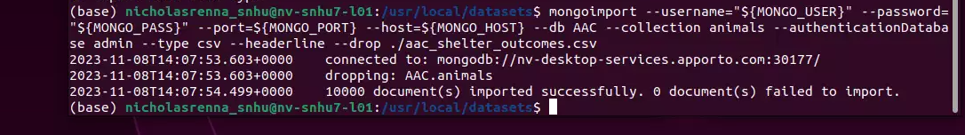

1. Create an admin and user account with read and write privileges. You need to use the admin account to create new users.

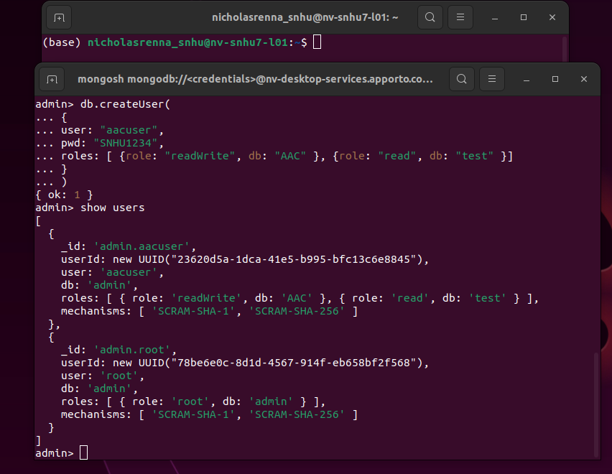

1. Download Python Module: animalShelter.py or create your own with CRUD commands. See tools and Rationale step 2. Make sure to include the PyMongo drivers for communication and the Mongoclient see below:

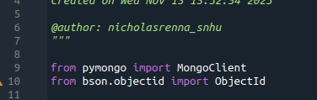

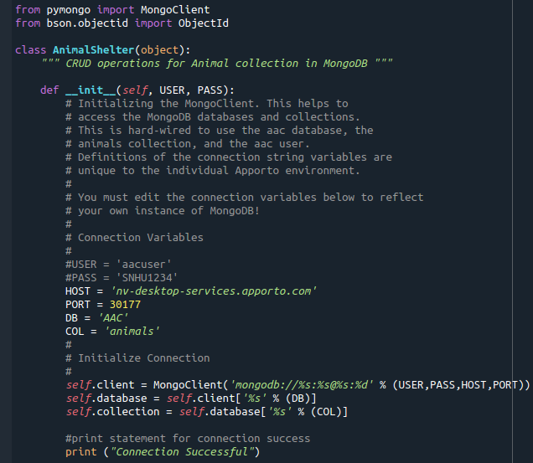

1. Update username, password, host, port, database, and collection from the Python Module:



1. Make sure Read command in the Python module works with CRUD.read({}) to return all documents from MongoDB:

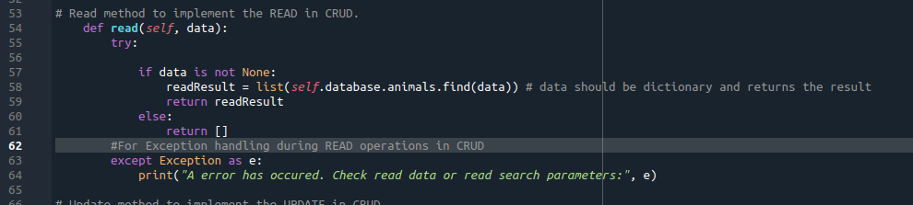

1. Start Jupyter notebook and code in username and password and make sure to import your Python module.

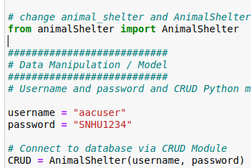

1. Place HTML image tag for product Logo in app layout:

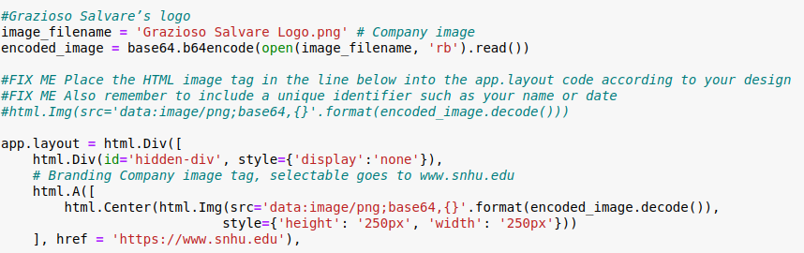

1. Create a dropdown menu and a unique identifier. Dash Components for interaction

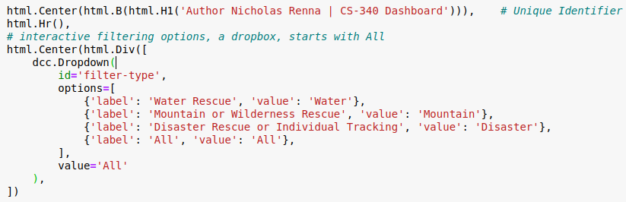

1. Data Table features for the application.

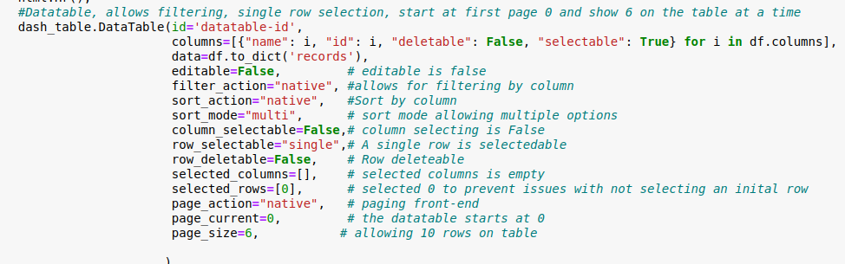

1. Div container to set up charts and data table. Placement div containers.

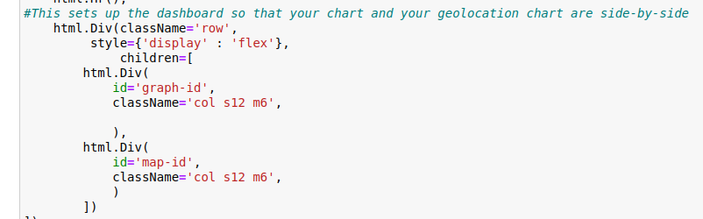

1. Query function for filtering: Showing one.

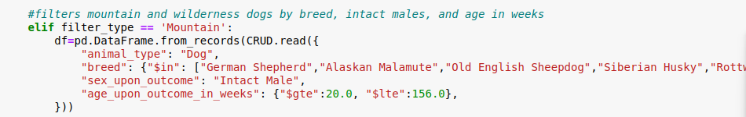

1. App callback to update data table. Allows the changes to happen from the data table to the query function

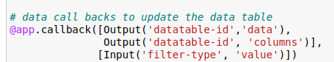

1. Pie chart function and app callback (used to call back actions taken from the data table to the pie chart).

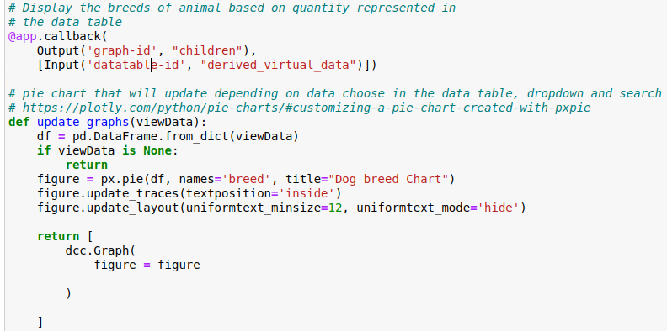

1. Map function and app callback:

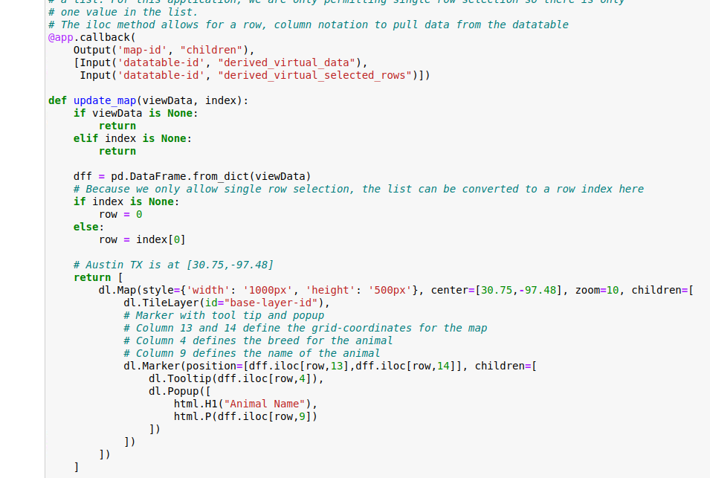

## Application walkthrough

Our client Grazioso Salvare has requested to have a Dashboard logo including a URL anchor tag that goes to the client’s home page (snhu.edu). The client also wants a unique identifier of the creator of the Application and an interactive filtering option to filter the Austin Animal Center outcomes dataset. The filtering options are below in a table format. Reset is also included which will bring the data set back to its original state.

|  |  |  |  |
| --- | --- | --- | --- |
| **Rescue Type** | **Preferred Breeds** | **Preferred Sex** | **Training Age** |
| Water | Labrador Retriever Mix, Chesapeake Bay Retriever, Newfoundland | Intact Female | 26 weeks to 156 weeks |
| Mountain or Wilderness | German Shepherd, Alaskan Malamute, Old English Sheepdog, Siberian Husky, Rottweiler | Intact Male | 26 weeks to 156 weeks |
| Disaster or Individual Tracking | Doberman Pinscher, German Shepherd, Golden Retriever, Bloodhound, Rottweiler | Intact Male | 20 weeks to 300 weeks |

The data table needs to dynamically respond to the filtering options. Also, a geolocation map and a pie chart were created and will also dynamically respond to filtering options once an end user interacts with the data. Any time the data table’s data changes the pie chart will change to support the data in the table and whichever dog is selected the map will reflect that change. Next, we will show our animalShelter Dashboard application in action.

Application start:

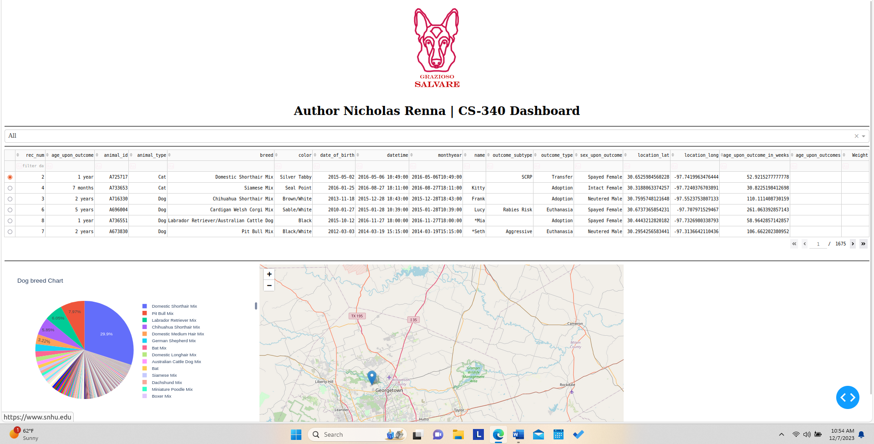

Drop down menu engaged:

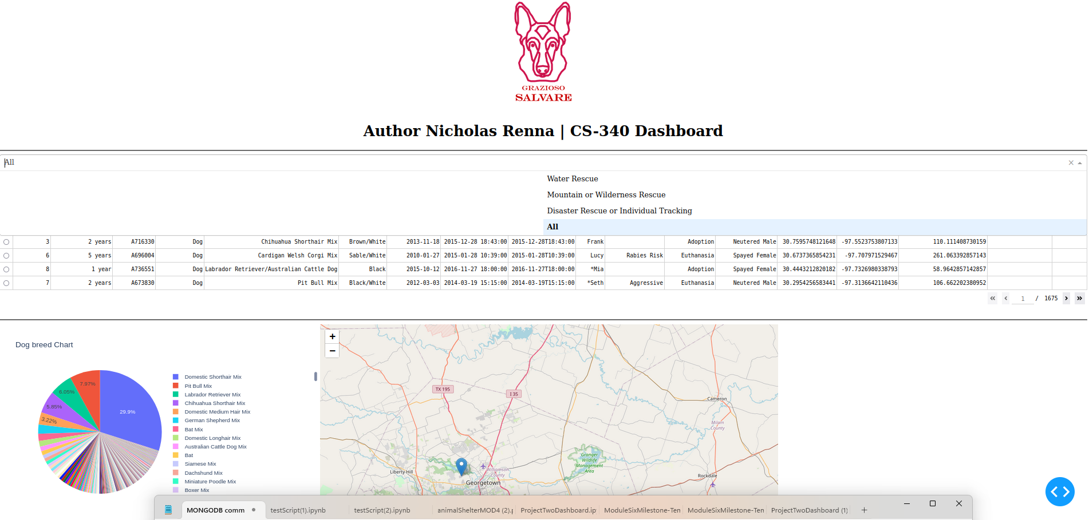

**All** from dropdown menu: If user selects all, the data table goes back to unfiltered state and the pie chart updates with the data from the table. The map will update depending on which row is selected.

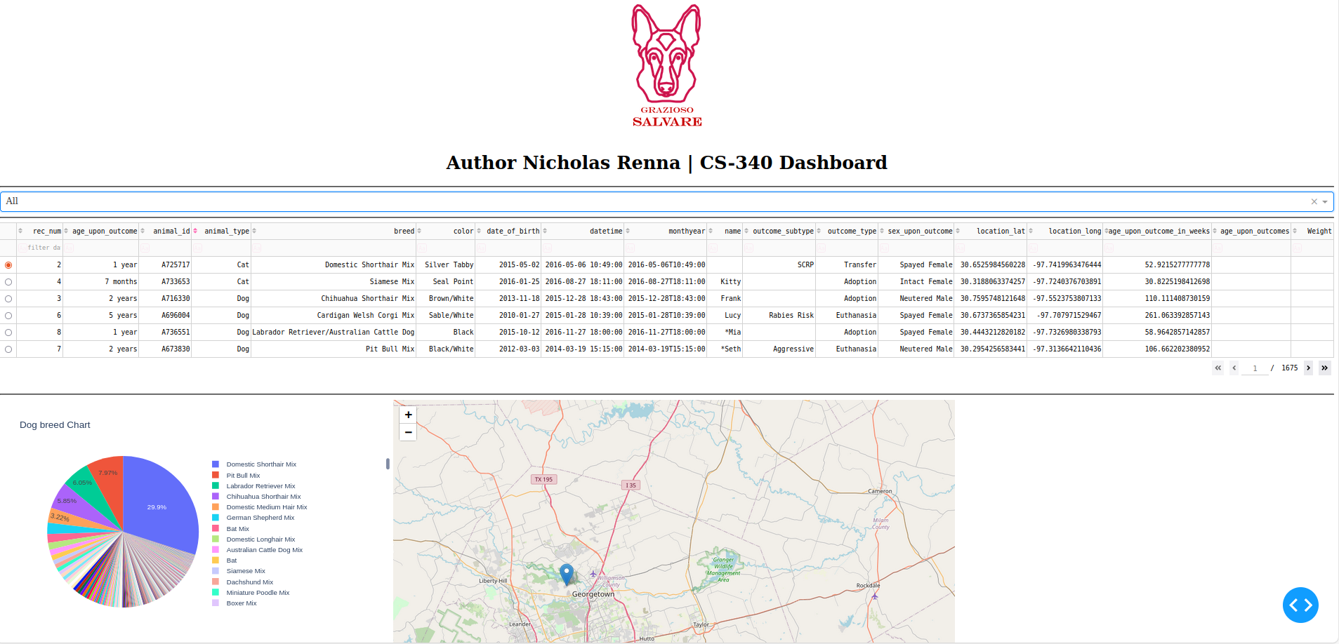

**ALL** section: Close-up of the pie chart with all available dog breeds, and map updates depending on dog or cat selected.

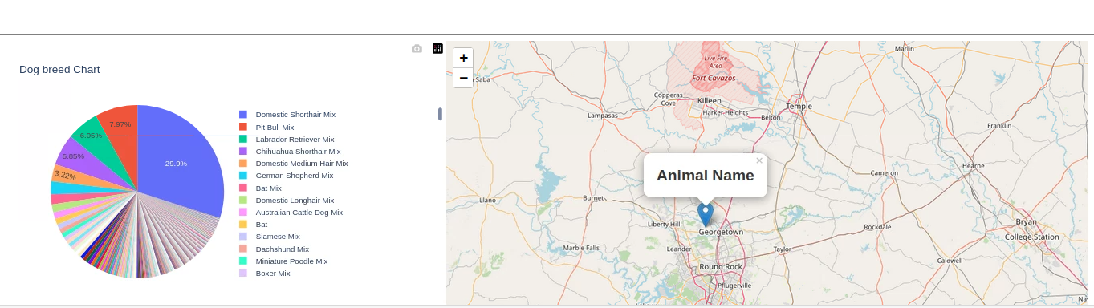

**Water Rescue** from the dropdown menu: First the data table updates with the filtering to water rescue and then the pie chart updates from the data in the data table, next the map updates to reflect the first dog inside the data table.

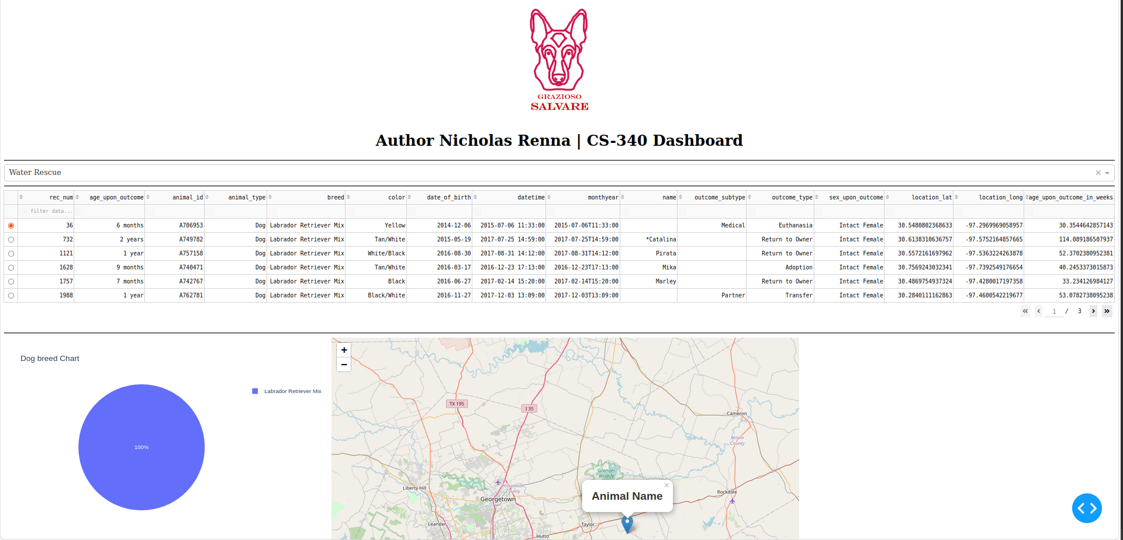**Water Rescue**: Currently only Labrador Retriever mixes are available for water rescue. Map will update as the data changes in the table, here the first Labrador Retriever mix has no name.

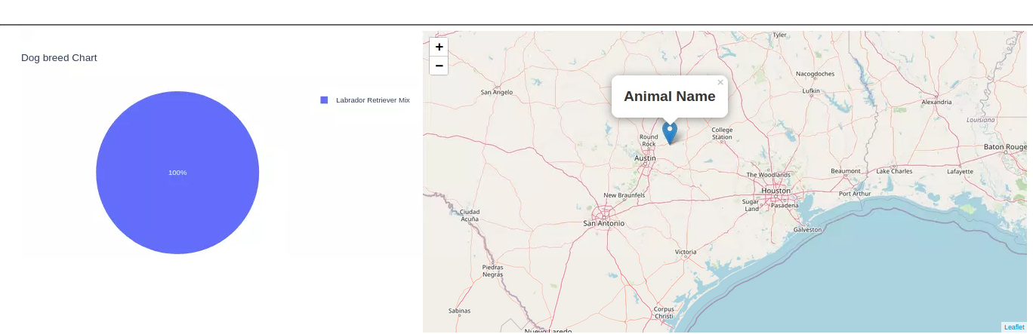

**Mountain or Wilderness Rescue** from the dropdown menu**:** The user can select mountain or wilderness recure and the data table will update with available dogs, then the pie chart will update gives the user an extra perspective and last the map will update with the row that is selected in the table.

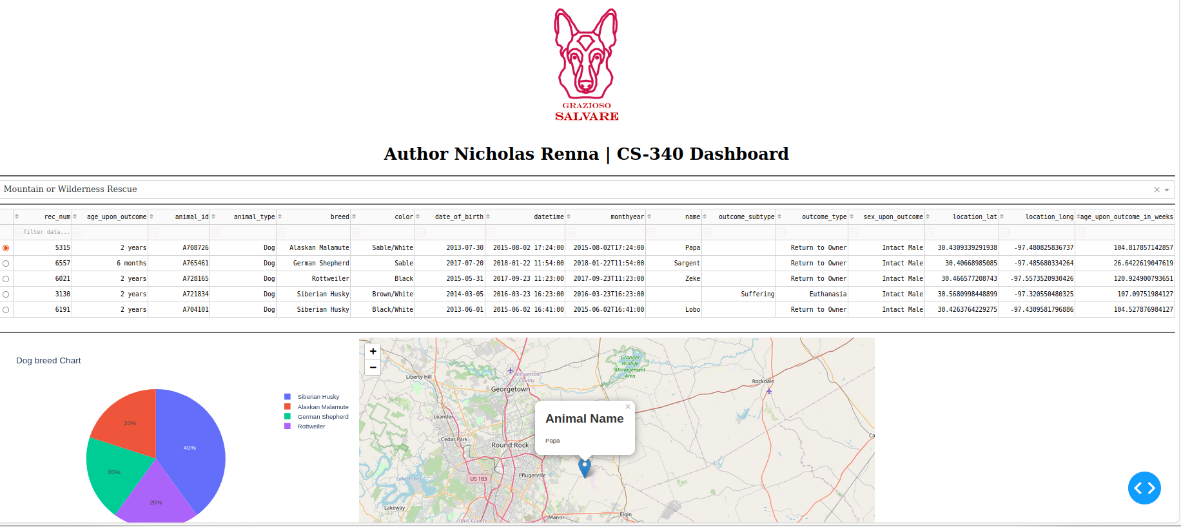

**Mountain or Wilderness Rescue:** Updates the pie chart with 6 available dogs and four different breeds. The map shows the first dog in the table, or the user can select another dog and the map updates the new location.

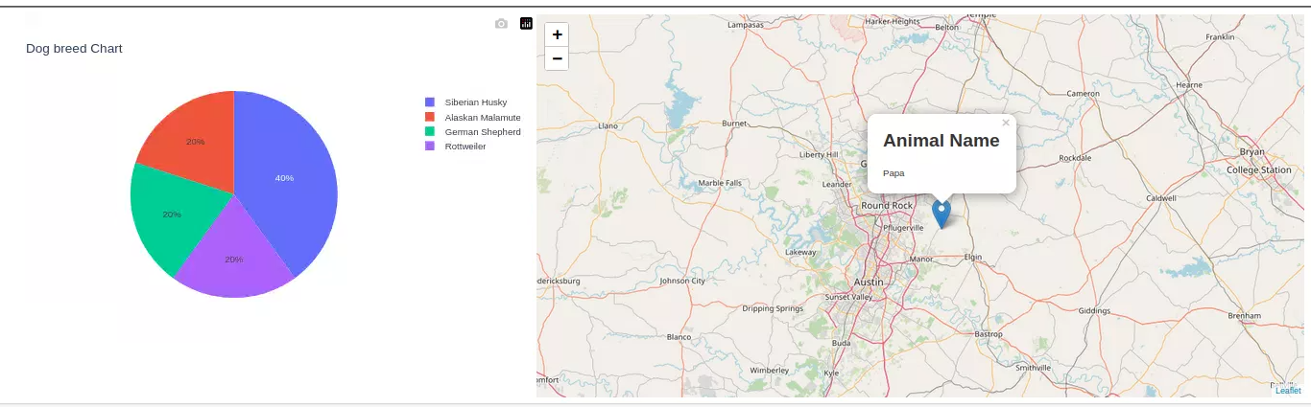

**Disaster Rescue or Individual Tracking** from the dropdown menu: The user will select the disaster rescue or individual tracking from the dropdown and the data table will update with the available dogs, then the pie chart will update from the data in the table and last the map will reflect the dog that is chosen in the data table.

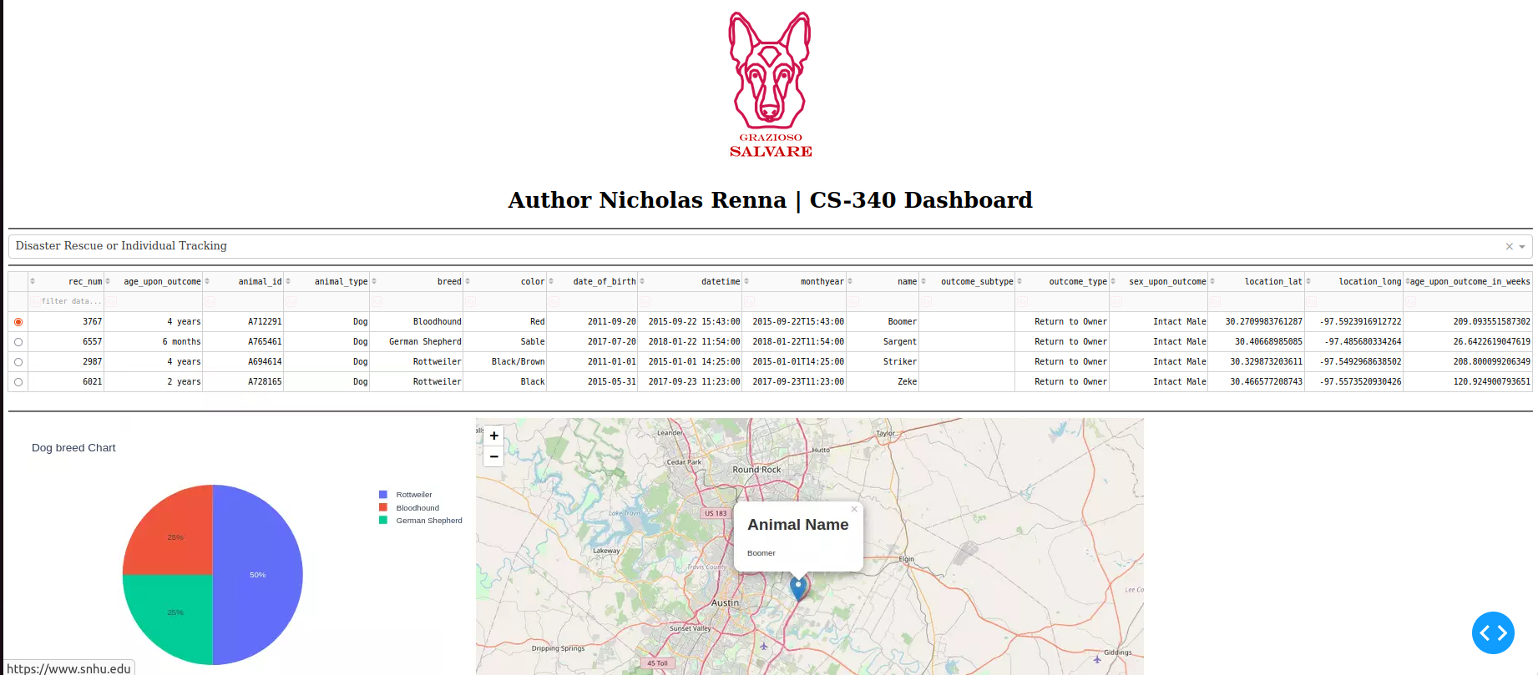**Disaster Rescue or Individual Tracking:** Close up of the pie chart changes with new selection, map updates too.

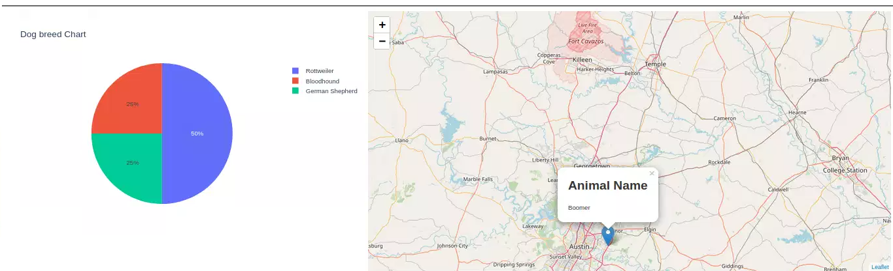

**Geolocation Map**: The user can select a dog or cat from the data table and the map will reflect the selection and respond with the location of the animal. The screenshot below shows the first and second dog and the map reflects the changes. The two pop-up messages show the animal’s name and breed.

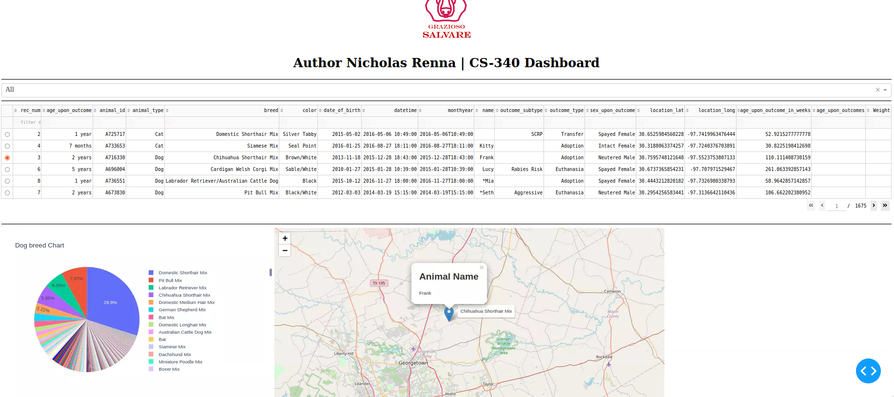

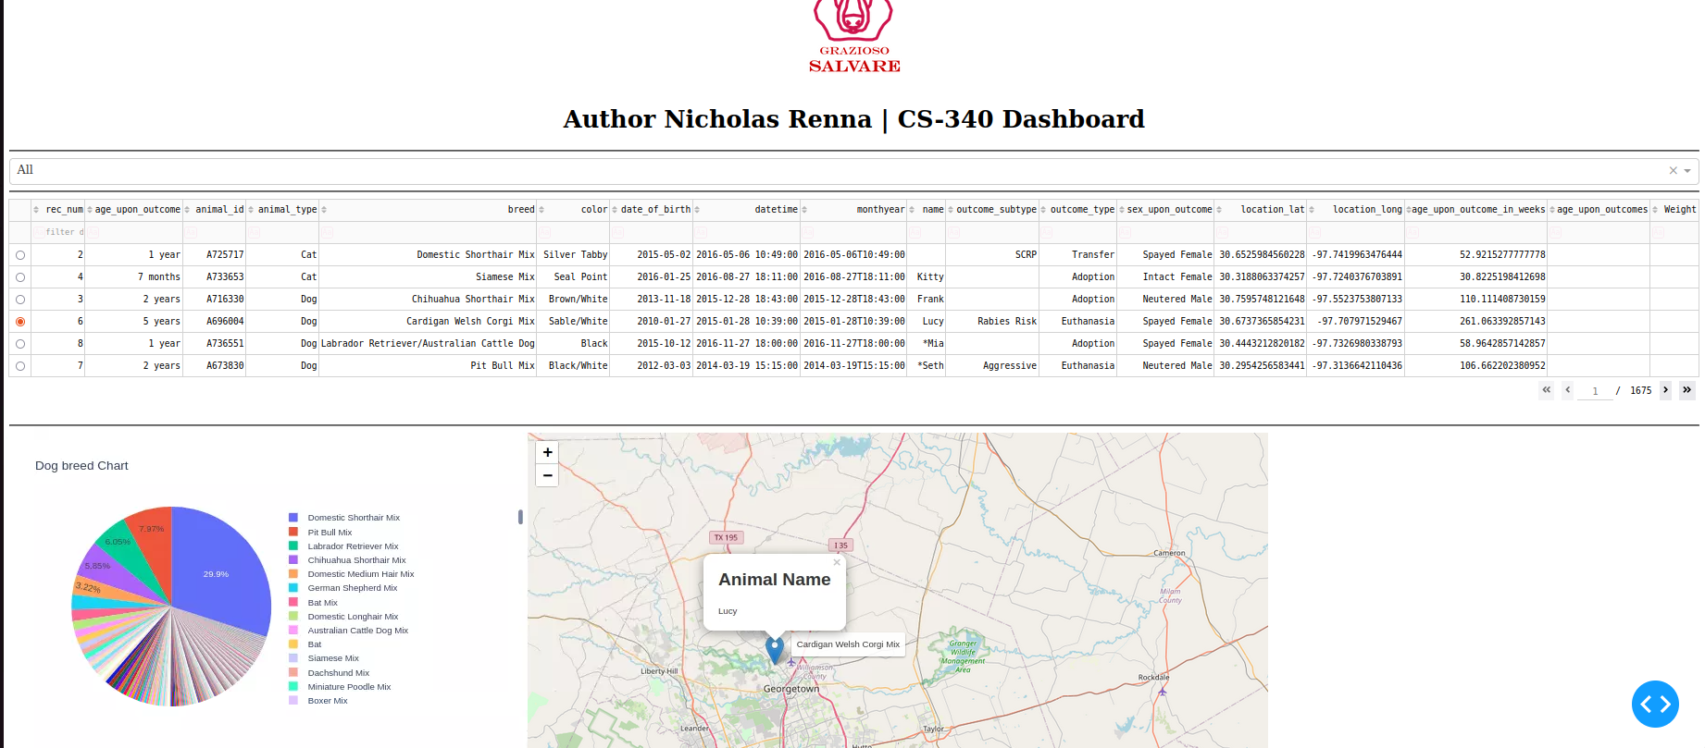

**Using the filter search on the table:** Searching for dogs named lucy, Pie chart updates with different dog breeds, as does the map when a dog is selected.

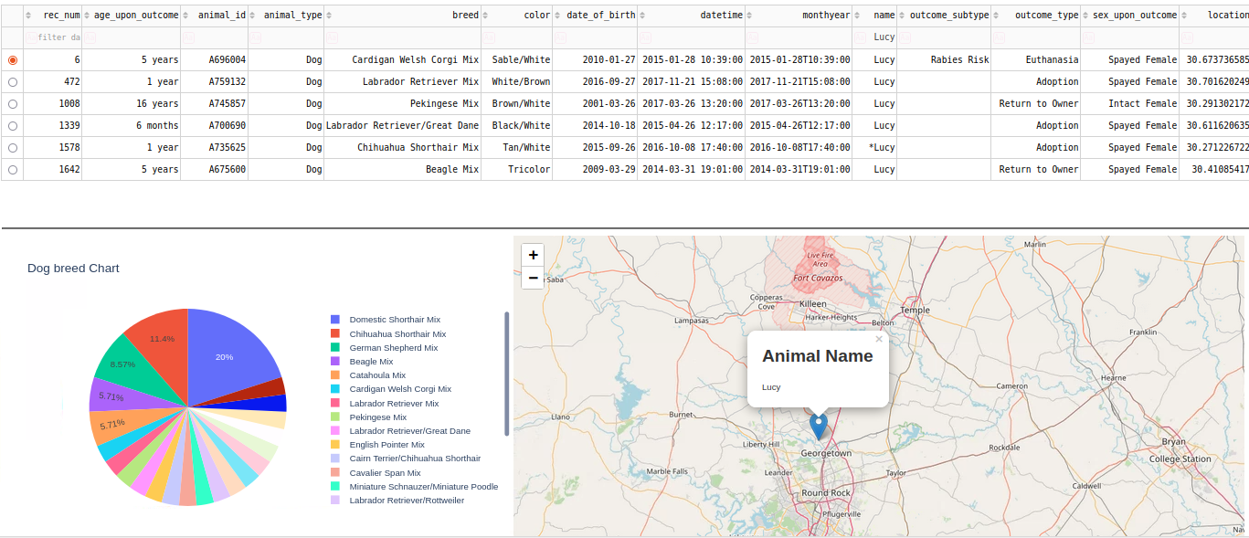

**Pie chart update**: If a user searches for a dog breed such as Newfoundland, then all the dogs with that breed in them will update on the chart. In the second screenshot it shows that the pie chart updates when a user searches for a dog’s age such as 1. The data table updates the search and then the charts update as well.

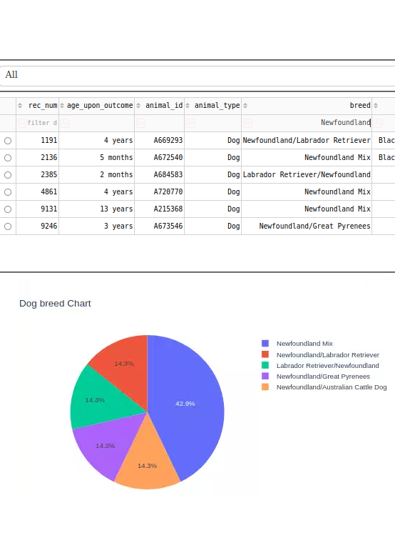

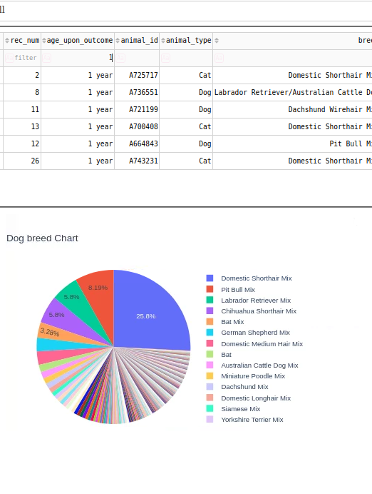

**Challenges**

A challenge that I encountered was with my Python module in the read function. The function for my dashboard application needs to have a {“_id”:0}, included in the read result for the application to work. Also, I had to comment out a line from the Dashboard code which drops the _id column. I overcame this challenge by reading the discussion post in class and trying out a few different options until I found the one willing to work with my application. Another challenge was finding a way to make the logo clickable and move to another page in this case snhu.edu. I remember some work I did in another course that involved HTML and CSS and I ended using a (href) and then I needed to figure out where to put it by trial and error. Filtering the data is a challenge because in the spec sheets it only has relative information about the kinds of dogs that Grazioso Salvare needs filtered. For example, water from my dropdown only finds labrador retriever mix because the other kinds of dogs are mixes. Although the dogs must pass the criteria (sex and age requirements) for the query function to find them.

### Contact

Your name:

Nicholas Renna

CS340 Client/Server Development

[nicholas.renna@snhu.edu](mailto:nicholas.renna@snhu.edu)

**References:**

Ramos. L. Python and MongoDB: Connecting to NoSQL Databases. Realpython.com [Python and MongoDB: Connecting to NoSQL Databases – Real Python](https://realpython.com/introduction-to-mongodb-and-python/#:~:text=MongoDB%20is%20a%20document%2Doriented%20database%20classified%20as%20NoSQL.,to%20organize%20and%20store%20data.)

**Link:**

For MongoDB: [MongoDB: The Developer Data Platform | MongoDB](https://www.mongodb.com/)

For Python: [Welcome to Python.org](https://www.python.org/)

For Jupyter: [Project Jupyter | Home](https://jupyter.org/)

For Plotly:

* [Dash Core Components | Dash for Python Documentation | Plotly](https://dash.plotly.com/dash-core-components)
* [Dash DataTable | Dash for Python Documentation | Plotly](https://dash.plotly.com/datatable)
* [Pie charts in Python (plotly.com)](https://plotly.com/python/pie-charts/)

For Leafly: [Dash Leaflet (dash-leaflet-docs.onrender.com)](https://dash-leaflet-docs.onrender.com/)